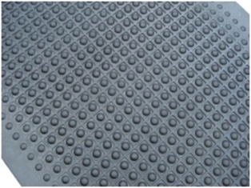

Anti Fatigue Bubble Mat

High Voltage - Insulating Mats (Electrical rubber mat)
